**Index**

Content Page No.

1. Home - 02

2. Product Details - 02

3. Search Product - 03-04

1 Home –

Show all Product from public API

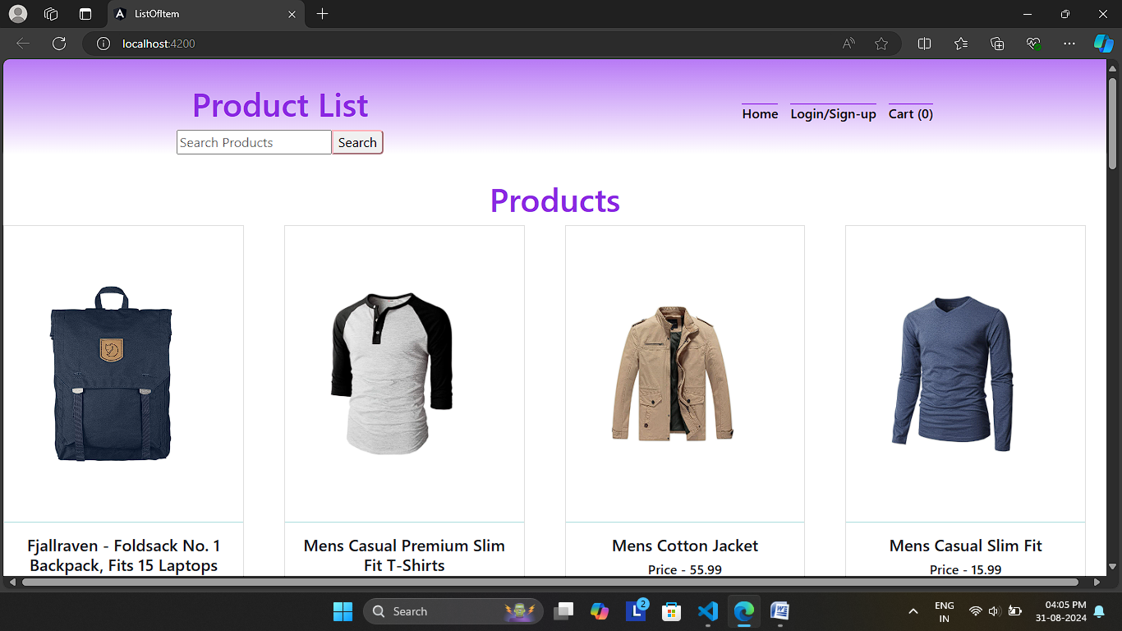

2 Product Details Page-

When user want see product Details they can Click any product image then Product details will be Open.

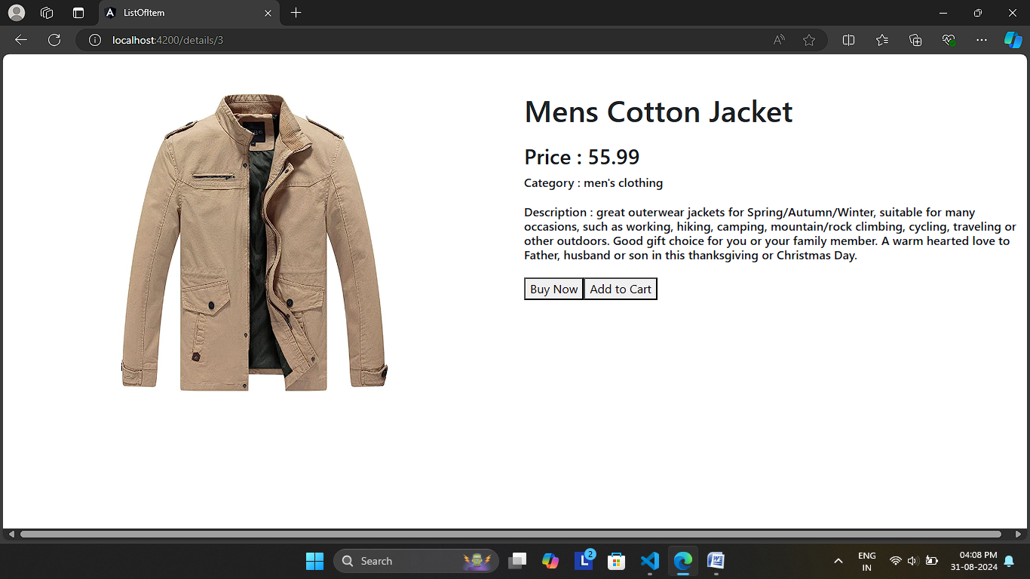

3 Search Product –

There are some category for Search Product

1. men's clothing
2. women's clothing
3. electronics
4. jewelery

In one Example for category - electronics-

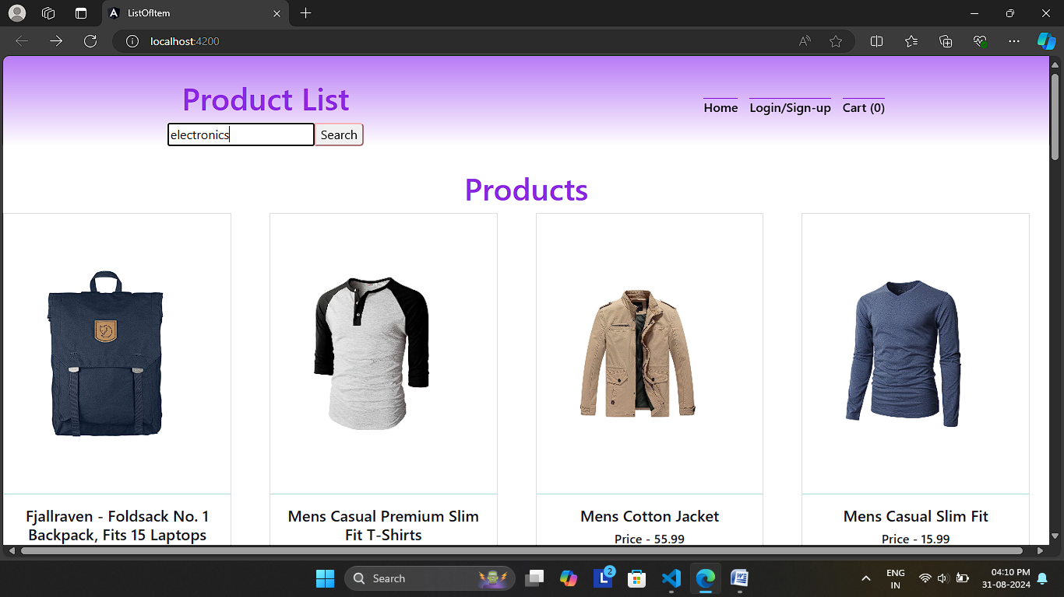

4 Search Result- 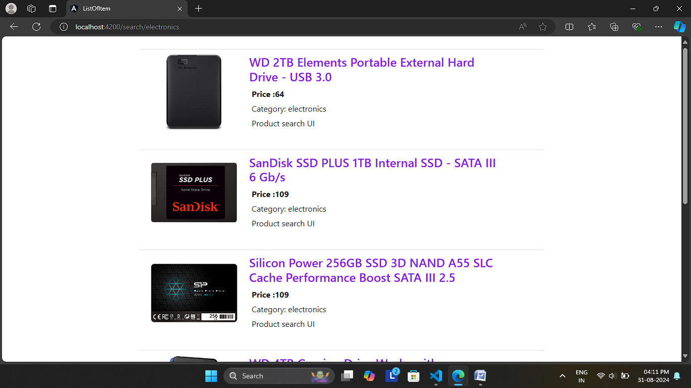

When user click on the product image or name he/she reaches the product detail page.

